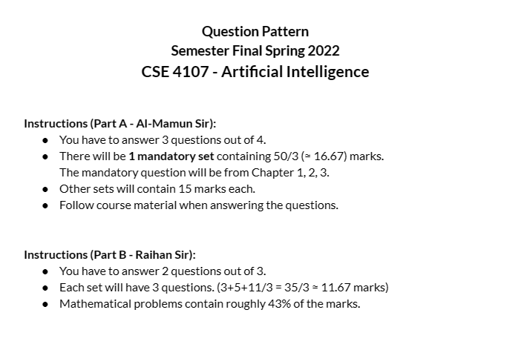

Part A

Chapter 01
- Describe two important environment contrasts that are generally considered for designing rational agents. [2]
Fully observable vs. partially observable: If an agent’s sensors give it access to the complete state of the environment at each point in time, then we say that the task environment is fully observable. A task environment is effectively fully observable if the sensors detect all aspects that are relevant to the choice of action. An environment might be partially observable because of noisy and inaccurate sensors or because parts of the state are simply missing from the sensor data—for example, a vacuum agent with only a local dirt sensor cannot tell whether there is dirt in other squares, and an automated taxi cannot see what other drivers are thinking.
Single-agent vs. multiagent: The distinction between single-agent and multiagent environments may seem simple enough. For example, an agent solving a crossword puzzle by itself is clearly in a single-agent environment, whereas an agent playing chess is in a two agent environment.
Deterministic vs. nondeterministic: If the next state of the environment is completely determined by the current state and the action executed by the agent(s), then we say the environment is deterministic; otherwise, it is nondeterministic. The word stochastic is used as a synonym for “nondeterministic,” but a model of the environment is stochastic if it explicitly deals with probabilities (e.g., “there’s a 25% chance of rain tomorrow”) and “nondeterministic” if the possibilities are listed without being quantified (e.g., “there’s a chance of rain tomorrow”).
Episodic vs. sequential: In an episodic task environment, the agent’s experience is divided into atomic episodes. In each episode the agent receives a percept and then performs a single action. Crucially, the next episode does not depend on the actions taken in previous episodes. For example, an agent that has to spot defective parts on an assembly line bases each decision on the current part, regardless of previous decisions; moreover, the current decision doesn’t affect whether the next part is defective. In sequential environments, on the other hand, the current decision could affect all future decisions. Chess and taxi driving are sequential: in both cases, short-term actions can have long-term consequences. Episodic environments are much simpler than sequential environments because the agent does not need to think ahead.
Static vs. dynamic: If the environment can change while an agent is deliberating, then we say the environment is dynamic for that agent; otherwise, it is static. Static environments are easy to deal with because the agent need not keep looking at the world while it is deciding on an action, nor need it worry about the passage of time. Dynamic environments, on the other hand, are continuously asking the agent what it wants to do; if it hasn’t decided yet, that counts as deciding to do nothing.
Discrete vs. continuous: The discrete/continuous distinction applies to the state of the environment, to the way time is handled, and to the percepts and actions of the agent. For example, the chess environment has a finite number of distinct states (excluding the clock). Chess also has a discrete set of percepts and actions. Taxi driving is a continuous-state and continuous-time problem: the speed and location of the taxi and of the other vehicles sweep through a range of continuous values and do so smoothly over time.
Rational Agent
1) A rational agent chooses actions that optimize expected performance given percept sequence and knowledgebase at the time.
2) It learns, that is, improves performance based on experience.
3) It functions autonomously.
A rational agent is an agent that chooses actions that optimize expected performance given the percept sequence and knowledge base at the time. The following are the characteristics of a rational agent:
- Maximizes Expected Utility: A rational agent always seeks to maximize its expected utility, which is the sum of the utilities of all possible outcomes weighted by their probabilities.
- Considers Knowledge and Percepts: A rational agent takes into account its prior knowledge and the sequence of percepts it has received from its environment when making decisions.
- Autonomous: A rational agent operates autonomously, which means it has the ability to act independently without any external intervention.
- Learning: A rational agent learns from its experiences, which enables it to improve its performance over time.
- Performance Measure: A rational agent is judged based on its performance measure, which defines the success criterion for the agent.
- Best Possible Actions: A rational agent always selects the best possible action given its current state and the available information.
- Rationality and Environment: The rationality of an agent is closely linked to the environment in which it operates. A rational agent must be designed with an understanding of the task environment in which it will operate, including the sensors to perceive the environment and the performance measure that defines the agent's success criteria.

Explain the necessity of thorough study of the environment of functioning before designing a rational Agent.
Before designing a rational agent, it is necessary to thoroughly study the environment of its functioning because the performance of the agent depends heavily on its ability to perceive and interact with the environment. Understanding the environment is essential for designing an agent that can make optimal decisions and achieve its goals.
Here are some reasons why a thorough study of the environment is important before designing a rational agent:
- Performance measure: The performance measure of an agent is defined by the success criteria of the task it is designed to perform. Understanding the environment helps in defining the performance measure appropriately, which is essential for evaluating the effectiveness of the agent.
- Prior knowledge: A rational agent needs to have prior knowledge of its environment to make optimal decisions. The agent needs to know the state of the environment, the available actions, and the potential consequences of those actions. Understanding the environment helps in defining the agent's prior knowledge and designing appropriate sensors for perceiving the environment.
- Best possible actions: To be rational, an agent must choose the best possible action to achieve its goal. Understanding the environment helps in identifying the best possible actions and designing appropriate decision-making mechanisms for the agent.
- Sequence of percepts: The sequence of percepts received by the agent depends on the environment. Understanding the environment helps in designing appropriate sensors and perception mechanisms for the agent.
- Environment contrasts: The environment can have various contrasts, such as fully observable or partially observable, deterministic or stochastic, episodic or sequential, static or dynamic, and discrete or continuous. Understanding these contrasts is essential for designing an agent that can handle the specific characteristics of the environment effectively.
In summary, a thorough study of the environment is necessary before designing a rational agent because it helps in defining the performance measure, agent's prior knowledge, best possible actions, sequence of percepts, and handling environment contrasts. This knowledge is essential for designing an agent that can make optimal decisions and achieve its goals.

Elaborate the concept of Rational Agents
For each possible percept sequence, a rational agent should select an action that is expected to maximize its performance measure, given the evidence provided by the percept sequence and whatever built-in knowledge the agent has.
Consider the simple vacuum-cleaner agent that cleans a square if it is dirty and moves to the other square if not. Let us assume the following:
The performance measure awards one point for each clean square at each time step, over a “lifetime” of 1000 time steps.
The “geography” of the environment is known a priori but the dirt distribution and the initial location of the agent are not. Clean squares stay clean and sucking cleans the current square. The Right and Left actions move the agent one square except when this would take the agent outside the environment, in which case the agent remains where it is.
The only available actions are Right, Left, and Pick Dirt. The agent correctly perceives its location and whether that location contains dirt. Under these circumstances the agent is indeed rational; its expected performance is at least as good as any other agent’s.

Analyze the role of issues related to environment of functioning in designing rational agents. [4.5]

Analyze the characteristics of a planner to establish that it is an intelligent agent. [4.5]
Planner (An intelligent agent):
- A planner is usually a goal-based agent
- A planner takes advantage of the structure and specific features of the problem domain to formulate the actions
- A planner follows the rule: Activities should be preconditioned
- A planner decomposes a problem into independent subproblems, and it achieves the goal by satisfying subgoals

Chapter 02
- Elaborate the concept of Unification? [2]

Unification is a process of making sentences equal using substitution. A unifier is a substitution that makes sentences equal.
Basic idea of the process:
- Different predicates or constants do not match.
- A variable matches a term if the term does not contain the variable itself.

- Why backward chaining algorithms are said to be goal oriented? [2]
Backward chaining is known as goal-driven technique because backward chaining starts from the goal and reaches the initial state in order to extract the facts.
Query → goal → conclusion → premise → subgoal → conclusion → premise → subgoal → backtracking → … until proved or KB exhausted

The algorithm begins with the query, which is the goal to be achieved, and then looks for the conclusion in the knowledge base that can lead to that goal. Once a conclusion is found, the algorithm searches for the premises that support that conclusion, and then repeats the process until all sub-goals are satisfied, or the algorithm exhausts the entire knowledge base without finding a solution.

- How is a Term defined in the syntax of First Order Logic? [2]
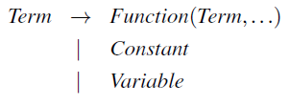
A term is a logical expression that refers to an object. Constant symbols are terms.
Terms are used in atomic sentences and are either constants, variables, or functions.
A complex term is formed by a function symbol followed by a parenthesized list of terms as arguments to the function symbol. Functions take one or more terms as input and produce a new term as output.

- Explain the matching rules that are involved during Unification. [2]

- Set θ = {}.
- If SUBST (θ, S) contains only one element, then stop; θ is an mgu of S. Otherwise, find the first disagreeing pair of SUBST (θ, S).
- If the disagreeing pair contains a variable v and a term t such that v does not occur in t (that is, t is another variable / a constant / a function without v), then obtain θ = θ ∪ {v /t} and go to step 2. Otherwise stop; S is not unifiable.

- How Resolution is used to prove or disprove a sentence? [2]
Resolution is a powerful inference rule used to prove or disprove a sentence in first-order logic (FOL). The goal of resolution is to derive a contradiction by finding two clauses that contain complementary literals, i.e., one clause contains a positive literal and the other contains its negation. When such a pair is found, resolution combines the two clauses by removing the complementary literals and forms a new clause, which is then added to the set of clauses.
To use resolution to prove a sentence, we first convert the knowledge base (KB) and the sentence of interest into conjunctive normal form (CNF), which is a conjunction of clauses, each of which is a disjunction of literals. Then, we add the negation of the sentence to the KB and try to derive a contradiction by repeatedly applying the resolution rule. If a contradiction is found, then the original sentence is true.
On the other hand, to use resolution to disprove a sentence, we first convert the sentence into CNF and then add it to the KB. We then try to derive a contradiction by applying the resolution rule. If a contradiction is not found, then the sentence is false.
Overall, resolution is a powerful and efficient tool for automated reasoning in FOL, and it is used in various applications such as theorem proving, automated reasoning, and artificial intelligence.
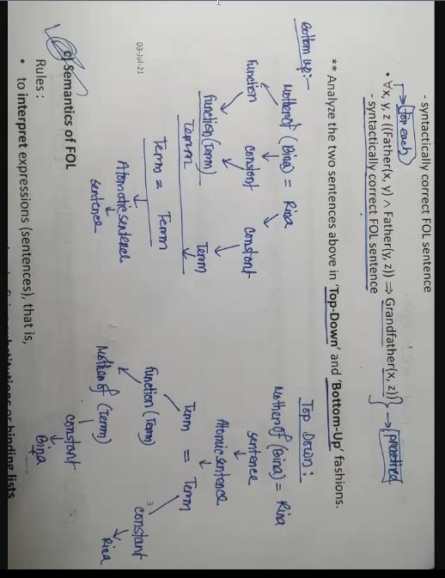
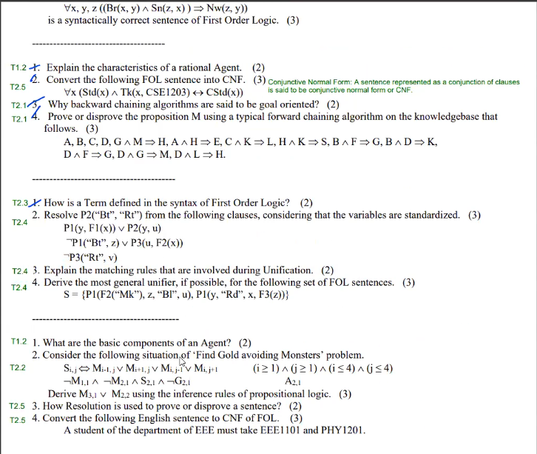

Chapter 03
Justify the naming of the search strategy called Genetic Algorithms. You can get idea from this.
The naming of the search strategy called Genetic Algorithms is justified by the fact that the algorithm is inspired by the principles of genetics and evolution. The algorithm models reproduction involving two parents, and a successor state is generated by combining two states in a process similar to the genetic crossover process in biological reproduction.
The algorithm also models evolution, using principles of population genetics and survival of the fittest. Parent states are chosen from a population and evaluated using a fitness function, which rates the quality of the solutions represented by the states. The fittest individuals are then selected to produce offspring for the next generation, while weaker individuals are removed from the population.
Furthermore, the algorithm uses mutation to introduce random changes in the population, similar to the process of genetic mutation in biological evolution. These changes can help the population explore new areas of the search space and avoid getting stuck in local optima.
Therefore, the name "Genetic Algorithms" accurately reflects the algorithm's principles, which are inspired by genetics and evolution. The algorithm uses genetic and evolutionary principles to guide the search for the optimal solution, making it a powerful and effective optimization technique.
Compare important features of Greedy Best first and A* search strategies in a table.
Greedy Best-First search and A* search are both informed search strategies that use heuristic information to guide the search for the solution. However, there are some important differences between the two strategies.
Here are some of the key features of Greedy Best-First search and A* search:
- Completeness:
- Greedy Best-First search is not complete because it may get stuck in a local maximum.
- A* search is complete because it explores all possible paths to the goal state.
- Optimality:
- Greedy Best-First search is not always optimal because it only considers the heuristic value of the current node and does not take into account the cost of the path from the start node.
- A* search is optimal if the heuristic function is admissible (never overestimates the true cost to the goal) and consistent (monotonically decreases as the search progresses).
- Memory requirements:
- Greedy Best-First search has low memory requirements because it only keeps track of the current best node and its successors.
- A* search has higher memory requirements because it keeps track of the f-value (sum of the g-value and h-value) of all nodes in the open list.
- Time complexity:
- Greedy Best-First search has a time complexity of O(b^m), where b is the branching factor and m is the maximum depth of the search tree.
- A* search has a time complexity of O(b^d) with a good heuristic, where d is the depth of the goal node.
- Heuristic:
- Greedy Best-First search uses an admissible heuristic function that estimates the distance to the goal node from the current node.
- A* search uses an admissible and consistent heuristic function that estimates the total cost of the path from the start node to the goal node.
- Algorithm:
- Greedy Best-First search expands the node with the best heuristic value first, without considering the cost of the path from the start node to the current node.
- A* search expands the node with the lowest f-value (sum of the g-value and h-value) first, taking into account both the cost of the path from the start node to the current node and the estimated cost from the current node to the goal node.
Overall, A* search is generally preferred over Greedy Best-First search because it is complete, optimal, and more efficient in terms of both time and memory requirements. However, Greedy Best-First search may still be useful in some situations where time and memory resources are limited and an approximate solution is acceptable.

Here is a table comparing the important features of Greedy Best-First and A* search strategies:

Feature | Greedy Best-First Search | A* Search
Completeness | Not complete | Complete
Optimality | Not always optimal | Optimal if the heuristic is admissible
Memory requirements | Low | High
Time complexity | O(b^m) | O(b^d) (with a good heuristic)
Heuristic | Admissible heuristic, but not always consistent | Admissible and consistent heuristic
Algorithm | Expands node with the best heuristic value first | Expands node with the lowest f value
In summary, A* search is typically preferred over Greedy Best-First search because it is complete, optimal (with an admissible and consistent heuristic), and more efficient in terms of both time and memory requirements. However, Greedy Best-First search may be preferred in cases where time and memory resources are limited and the quality of the solution is not a major concern.

c) Action Schemas:
i) Action: Load(c, p, a)
Precondition: Cargo(c) ∧ Plane(p) ∧ Airport(a) ∧ At(a, c) ∧ At(a, p)
Effect: ¬At (a, c) ¬ In(p, c)

"Action Schemas" is a concept used in Artificial Intelligence, specifically in the field of Planning and Scheduling. An Action Schema is a description of an action that can be taken in a given environment.
The Action Schema "Load(c, p, a)" is a specific action that represents loading cargo (c) onto a plane (p) at an airport (a). The precondition of this action states that the cargo (c) must be present, the plane (p) must be present, the airport (a) must be present, the cargo (c) must be at the airport (a), and the plane (p) must also be at the airport (a).
The effect of this action is that the cargo (c) is no longer at the airport (a) and is now in the plane (p). This effect is represented as "¬At (a, c) ¬ In(p, c)".
Action: Unload(c, p, a)
Precondition: Cargo(c) ∧ Plane(p) ∧ Airport(a) ∧ At(a, p) ∧ In(p, c)
Effect: At (a, c) ∧ ¬ In(p, c)
Action Schemas are a way to describe actions in a problem-solving domain. The given example describes two actions: Load and Unload.
"Load(c, p, a)" represents the action of loading a cargo "c" onto a plane "p" at an airport "a". The precondition for this action to take place is that the cargo "c" must exist, the plane "p" must exist, the airport "a" must exist, the cargo "c" must be at the airport "a", and the plane "p" must be at the airport "a".
"Unload(c, p, a)" represents the action of unloading a cargo "c" from a plane "p" at an airport "a". The precondition for this action to take place is that the cargo "c" must exist, the plane "p" must exist, the airport "a" must exist, the plane "p" must be at the airport "a", and the cargo "c" must be inside the plane "p".
The effects of these actions are described in the final clauses. For Load, the effect is that the cargo "c" is no longer at the airport "a" and is now inside the plane "p". For Unload, the effect is that the cargo "c" is now at the airport "a" and is no longer inside the plane "p".

Action: Fly(p, from, to) Precondition: Plane(p) ∧ Airport(from) ∧ Airport(to) ∧ At(from, p) Effect: ¬ At (from, p) ∧ At(to, p)
Action "Fly(p, from, to)" is an action schema in a problem-solving domain that involves planes, cargo, and airports. This action requires certain preconditions to be met before it can be executed. These preconditions are: the existence of a plane (p), two airports (from and to), and the plane's current location being at the departure airport (from).
The effect of executing the Fly(p, from, to) action is that the plane is no longer at the departure airport (from) and is now located at the destination airport (to). The effect can be represented as ¬ At (from, p) ∧ At(to, p), where the negation symbol (¬) represents the absence of a state.
This action schema can be used in a problem-solving context where a plane needs to fly from one airport to another, possibly to transport cargo. The preconditions ensure that the action is only taken if the plane and airports exist, and the plane is currently located at the departure airport. The effect of the action updates the state of the world by changing the location of the plane.

Genetic algorithms for optimization problems in large and complex search spaces technique does not require an explicit model of the search space or the objective function, unlike traditional optimization techniques such as gradient descent or linear programming. Instead, genetic algorithms use a population-based approach to explore and search for solutions in a more global and robust manner.
The process involves creating a population of potential solutions to the problem and applying genetic operators such as mutation, crossover, and selection to evolve and improve the population over generations. In each generation, the individuals with the highest fitness scores are selected to pass on their genetic information to the next generation, while fewer fit individuals are eliminated.

Chapter 04
Action: Move(b1, x, b2)
Precondition: Block(b1) ∧ Block(b2) ∧ On(x, b1) ∧ Clear(b1) ∧ Clear(b2)
Effect: On(b2, b1) ∧ ¬ On(x, b1) ∧ Clear(x) ∧ ¬Clear(b2)
i) Action: Move(b1, x, b2) describes the process of moving a block x from block b1 to block b2. The precondition of this action requires that block b1 and block b2 exist, block x is on block b1, block b1 is clear, and block b2 is also clear. The effect of this action is that block x is now on block b2, block b1 is no longer occupied by block x, block x is now clear, and block b2 is no longer clear.

ii) Action: MoveToTable(b1, b2)
Precondition: Block(b1) ∧ Block(b2) ∧ On(b2, b1) ∧ Clear(b1)
Effect: On(Table, b1) ∧ ¬ On(b2, b1) ∧ Clear(b2)
Action Schemas are a set of rules or templates for representing possible actions in a problem domain.
ii) Action: MoveToTable(b1, b2) describes the process of moving a block b1 from block b2 to a table. The precondition of this action requires that both block b1 and block b2 exist and block b2 is on block b1, and block b1 is clear. The effect of this action is that block b1 is now on the table, block b2 is no longer on block b1, and block b2 is now clear.

How a planner exerts intelligence through domain feature consideration?
A planner exerts intelligence through domain feature consideration by considering relevant information and making informed decisions based on that information to achieve the goal. This involves understanding the properties of the problem domain, such as available actions, states, and objectives, and using that knowledge to generate a plan. For example, a planner can take into account factors such as cost, efficiency, and constraints to determine the best plan for achieving the goal. The planner can also use heuristics, such as prioritizing actions that are more likely to lead to the goal, to guide the search process and make more informed decisions. Ultimately, a planner's ability to consider relevant domain features is what enables it to generate an optimal plan and exert intelligence in problem-solving.
A planner's intelligence lies in its ability to make informed decisions about the problem domain. This involves considering relevant information about the problem, such as available actions, states, and objectives, and using that information to generate a plan that is optimized to achieve the goal. The planner can also use heuristics to prioritize certain actions that are more likely to lead to the goal and make more informed decisions. By taking into account all relevant information and making informed decisions, a planner can generate an optimal plan and exhibit intelligence in problem-solving.
Why game playing problems are considered adversarial search problems?
Game playing problems are considered adversarial search problems because they involve two or more competing agents, where the actions of one agent can negatively impact the actions of the other agent. In these problems, the objective is to find a strategy that maximizes the chances of success, while considering the strategies of the opposing agent. This requires searching for the best move, taking into account the moves that the opposing agent might make in response. This type of problem is called adversarial because it involves making decisions in an uncertain environment, where the outcome is influenced by the actions of the opponent. The adversarial nature of these problems makes them more challenging than traditional search problems, as the search space is constantly changing and it is difficult to predict the outcome of a given move

How ‘precondition’ of actions are represented with PDDL?
In PDDL (Planning Domain Definition Language), the preconditions of an action are represented using a logical formula. This formula defines the conditions that must be satisfied in order for the action to be executed. The formula consists of a set of predicates, which describe the state of the world, and logical operators such as "∧" (and), "∨" (or), "¬" (not), etc.
For example, consider an action "Move(b1, x, b2)" with precondition "Block(b1) ∧ Block(b2) ∧ On(x, b1) ∧ Clear(b1) ∧ Clear(b2)". This means that in order for the action "Move" to be executed, the world must contain blocks b1 and b2, block x must be on top of block b1, and both blocks b1 and b2 must be clear (not occupied by any other block). The preconditions specify the necessary conditions for an action to be executed, ensuring that the action will only be performed when it is safe and meaningful to do so.

Elaborate the concept of quiescence search.
Quiescence search is a search technique used in game playing and decision-making AI systems to improve the efficiency and accuracy of their decision-making process. The concept of quiescence search is to avoid searching branches of the game tree that are unlikely to affect the outcome of the game, as they are in a state of "quiescence."
During a game, there are typically periods of time where the game state remains relatively unchanged, or "quiescent." These periods can be characterized by a lack of significant changes in the game state, such as moves made by pieces or changes in the score. Quiescence search exploits this property by avoiding unnecessary branching of the game tree during these periods, thus reducing the amount of computation required to determine the best move.
In quiescence search, a certain set of predefined "quiescence conditions" is used to identify when a state is quiescent. These conditions often include rules such as "no captures or checks," "no pawn moves," or "no moves that change the material balance of the game." Once a quiescent state is detected, the search is limited to only a small set of "quiet" moves, and the rest of the tree is not explored. This significantly reduces the amount of time and computational resources required to determine the best move.
In summary, quiescence search is a technique used to improve the efficiency and accuracy of game playing AI systems by avoiding unnecessary exploration of game states that are in a state of "quiescence."
How are states and actions of planning problems represented using PDDL (Planning Domain Definition Language)?
In PDDL (Planning Domain Definition Language), states and actions of planning problems are represented using predicates and operators, respectively.
States are represented as a set of predicates, where each predicate describes a specific aspect of the state. For example, the predicate "On(A, B)" means that block A is on block B, and "Clear(A)" means that block A is clear.
Actions are represented as operators, which are defined as a set of preconditions and effects. The preconditions specify the conditions that must be met before the action can be performed, and the effects describe the changes to the state that result from performing the action. For example, the action "Move(A, B)" may have preconditions "On(A, Table)" and "Clear(B)" and the effect "On(B, A) ∧ Clear(Table)".
Thus, PDDL provides a formal way of representing the states, actions, and relationships between them in a planning problem, which makes it easier for planners to process and reason about the problem.

Describe the general concepts, concerns and techniques of planning problems.
Planning problems are concerned with generating a sequence of actions to reach a desired goal state from an initial state in a well-defined environment. Planning problems are formalized as search problems and can be solved using search algorithms such as State Space Search, Heuristic Search, and Constraint Satisfaction.
The main concepts in planning include:
- Initial state: A representation of the initial conditions of the environment
- Goal state: A representation of the desired end-condition of the environment
- Actions: A set of operations that can be applied to the state to move from one state to another
- State space: The set of all possible states that can be reached through a sequence of actions
- Transition model: A mathematical representation of the effects of applying an action to a state
- Heuristics: A method for guiding the search process to optimize the outcome.
- Cost function: A measure of the cost of applying a particular action to reach a goal
The main concerns in planning are:
- Completeness: Ensuring that the planning algorithm will find a solution if one exists
- Optimality: Finding the best solution in terms of cost or other performance metrics
- Efficiency: Ensuring that the planning algorithm is able to find a solution in a reasonable amount of time
The main techniques used in planning include:
- State Space Search: A technique for finding a solution by exploring the state space and testing each state against the goal conditions.
- Heuristic Search: A technique for finding a solution by using a heuristic function to guide the search process and prioritize promising states.
- Constraint Satisfaction: A technique for finding a solution by enforcing constraints on the possible states and actions.
Overall, planning problems require the consideration of multiple factors and the use of sophisticated algorithms to find optimal solutions. The techniques used in planning are constantly evolving, and new approaches are being developed to tackle more complex and challenging problems.

Illustrate with examples various aspects of problem representation and plan generation for the Air cargo Transportation and Blocks World Tower Building Problems.
Problem representation for the Air Cargo Transportation Problem:
- States: A state in this problem represents the current configuration of planes, airports, and cargoes. For example, a state could be represented as: At(Plane1, Airport1) ∧ In(Plane1, Cargo1) ∧ At(Airport2, Cargo2)
- Actions: The actions in this problem describe how to move the cargoes and planes between different airports. For example, the actions Load, Unload and Fly describe how to load and unload cargoes and fly between different airports respectively.
- Goals: The goal in this problem is to transport the cargoes from their initial location to the desired destination. For example, the goal state could be represented as: At(Plane1, Airport2) ∧ In(Plane1, Cargo1) ∧ At(Airport3, Cargo2)
Plan generation for the Air Cargo Transportation Problem:
- Search algorithms: Search algorithms, such as A* search, can be used to find a plan for this problem. The algorithm starts from the initial state and generates a search tree where each node represents a state, and each edge represents an action. The algorithm generates children nodes by applying actions on the current node, and the search continues until the goal state is reached.
- Heuristics: Heuristics can be used to guide the search process and make it more efficient. For example, a heuristic could be used to prioritize actions that are more likely to lead to the goal state.
- Cost function: A cost function can be used to evaluate the cost of different plans. For example, the cost function could take into account the time required to transport the cargoes and the cost of flying between different airports.
Problem representation for the Blocks World Tower Building Problem:
- States: A state in this problem represents the current configuration of blocks. For example, a state could be represented as: On(Block1, Block2) ∧ On(Table, Block3) ∧ Clear(Block4)
- Actions: The actions in this problem describe how to move blocks and build towers. For example, the actions Move and MoveToTable describe how to move blocks between different locations and move blocks to the table respectively.
- Goals: The goal in this problem is to build a tower of blocks in a specified configuration. For example, the goal state could be represented as: On(Block3, Block2) ∧ On(Block2, Block1) ∧ On(Table, Block4)
Plan generation for the Blocks World Tower Building Problem:
- Search algorithms: Search algorithms, such as Depth-First Search or Breadth-First Search, can be used to find a plan for this problem. The algorithm starts from the initial state and generates a search tree where each node represents a state, and each edge represents an action. The algorithm generates children nodes by applying actions on the current node, and the search continues until the goal state is reached.
- Heuristics: Heuristics can be used to guide the search process and make it more efficient. For example, a heuristic could be used to prioritize actions that are more likely to lead to the goal state.
- Cost function: A cost function can be used to evaluate the cost of different plans. For example, the cost function could take into account the number of actions required to build the tower.
Quiescence search
Quiescence search is a technique used in game playing algorithms to handle situations where the state of the game is not stable and can change rapidly. A quiescent state is one where there are no major captures or changes in the game board in the immediate future. In quiescence search, the search algorithm goes deeper in the search tree until it reaches a quiescent state, and then evaluates the state using a heuristic evaluation function.
The cutoff test is used to limit the depth of the search tree, and quiescence search is used to evaluate states that are at the cutoff depth. This technique is used to reduce the search space and improve the efficiency of the search algorithm. The heuristic evaluation function is used to estimate the expected utility of the state, based on features such as material values or position of pieces in the game.
Overall, quiescence search is an effective technique for game playing algorithms, as it allows the algorithm to handle complex situations where the state of the game is not stable and can change rapidly.

Describe and illustrate with an example the representation of a two-player board game.
A two-player board game can be represented using the following components:
- Game state: This describes the current position of the pieces on the board, who has the turn to play and any other relevant information. For example, in a game of chess, the game state would consist of the position of all the pieces on the board, whose turn it is to move, and any special moves that have been made, such as castling or en passant.
- Game rules: These define the set of allowed moves that can be made, any restrictions or limitations on those moves, and how the game progresses. For example, in chess, the rules specify that only one piece can be moved at a time, that pieces can only move to certain squares, and that the objective is to checkmate your opponent's king.
- Game tree: This represents all the possible moves that can be made in the game, and the resulting game states. The root node of the tree represents the initial game state, and the branches represent possible moves that can be made. The leaves of the tree represent the final game states, such as a win, loss or draw.
Example: Consider a simple two-player board game called "Nim". The game is played on a number of piles, each containing a number of stones. The players take turns removing stones from a pile, with the goal of taking the last stone.
The game state would consist of the number of stones in each pile. The game rules specify that a player can only remove one or more stones from one pile per turn. The game tree would represent all the possible moves that can be made and the resulting game states.
In this example, the game representation can be used to determine an optimal strategy for playing the game, such as using a minimax algorithm to determine the best move to make at each step based on the state of the game and the game rules.

Explain with an example the major steps of the MINIMAX algorithm for finding optimal game strategies.
The MINIMAX algorithm is a decision-making algorithm used to find the optimal move for a player in a two-player, zero-sum game, such as chess or tic-tac-toe. The algorithm evaluates all possible game states, assuming that the opponent will choose the best move possible, and chooses the move that minimizes the maximum loss (hence the name MINIMAX). The steps of the MINIMAX algorithm are as follows:
- Define the game tree: A game tree is a graphical representation of all possible moves and the subsequent game states. It starts from the current state and expands to include all possible future states.
- Evaluate leaves: At the end of each branch of the game tree, we reach a leaf node, which represents a final game state. These nodes are evaluated, typically by assigning a numerical value to each state, with positive values indicating a win for the maximizing player, negative values indicating a win for the minimizing player, and 0 indicating a draw.
- Propagate values up the tree: The values of the leaf nodes are propagated up the tree, using the MINIMAX principle, which states that a player will choose the move that minimizes the maximum possible loss. The value of each non-leaf node is determined by the values of its children, with the maximizing player choosing the maximum value and the minimizing player choosing the minimum value.
- Select the best move: Once the values have been propagated up the tree, the algorithm reaches the root node, which represents the current state of the game. The move that leads to the child node with the highest value is selected as the optimal move.
For example, consider the game of tic-tac-toe. The game tree for a single move might look something like this:
perlCopy code
Current state | v Move 1 | v Child state 1 | v Move 2 | v Child state 2
In this example, the current state is represented by the root node, and the two possible moves are represented by the two child nodes. The value of each child node is determined based on the outcome of the game, with a win being assigned a positive value, a loss a negative value, and a draw 0. The MINIMAX algorithm would then propagate these values up the tree, selecting the move that leads to the child node with the highest value.

Describe important aspects of the MINIMAX algorithm, and explain how such a search strategy may be improved for practical purposes.
The MINIMAX algorithm is a search strategy used for finding the optimal move in two-player games, such as chess and checkers. It evaluates all possible moves and chooses the one that results in the best outcome for the current player, assuming that the opponent will play optimally in response.
The algorithm works by recursively exploring the game tree, with each node representing a game state. At each node, the algorithm calculates the minimax value, which is the maximum score that the current player can guarantee given the best play of the opponent. The algorithm then backtracks through the tree, selecting the move that results in the highest minimax value.
Some important aspects of the MINIMAX algorithm include:
- Game tree representation: The game tree is a tree-like representation of all possible game states and moves. The root node represents the current state of the game, and the children nodes represent possible future states.
- Terminal states: Terminal states are the final states of the game, and they are evaluated to determine the outcome of the game.
- Evaluation function: The evaluation function is used to determine the value of a game state. It assigns a numerical value to each state based on factors such as material advantage, mobility, and king safety.
- Pruning: Pruning is the process of removing branches of the game tree that are unlikely to result in the best move. This reduces the number of states that need to be evaluated and speeds up the search process.
To improve the MINIMAX algorithm for practical purposes, several techniques can be used:
- Alpha-beta pruning: This is an optimization technique that prunes branches that are unlikely to result in the best move. It reduces the number of states that need to be evaluated, making the search process faster.
- Transposition table: A transposition table is a data structure that stores previously evaluated game states and their values. This allows the algorithm to avoid revisiting states that have already been evaluated, making the search process more efficient.
- Endgame databases: Endgame databases are databases of precomputed endgame positions and their optimal moves. The MINIMAX algorithm can use these databases to avoid searching the entire game tree and instead find the optimal move directly.
- Quiescence search: Quiescence search is a technique that limits the depth of the search when the game is in a state of high activity. This helps to avoid searching branches that are unlikely to result in the best move, making the search process more efficient.

Illustrate the use of Alpha-Beta pruning for efficient search strategies for real games.
Alpha-Beta pruning is an optimization technique used in the MINIMAX algorithm to reduce the number of nodes that need to be evaluated in the game tree. The MINIMAX algorithm generates a complete game tree that shows all possible game states and their associated utility values, but evaluating all of these nodes can be computationally expensive, especially for large and complex games.
Alpha-Beta pruning is based on the observation that, in many cases, some parts of the game tree are not relevant for finding the optimal move, because the value of a parent node is determined by the values of its child nodes. The algorithm uses two values, alpha and beta, to keep track of the best move that the maximizing player (MAX) and the minimizing player (MIN) can guarantee, respectively.
Here is a simple example of how Alpha-Beta pruning can be applied in the game of Tic-Tac-Toe. Suppose that we want to find the optimal move for the MAX player (X), and the current game state is:
Copy code
X O X O X O X
We can use the MINIMAX algorithm to generate the game tree, and use alpha and beta values to prune the branches that are not relevant.
- Set alpha = -∞ and beta = +∞
- If the current node is a leaf node (a terminal state), return its utility value
- If the current node is a MAX node, set v = -∞ a. Generate all child nodes for this node b. For each child node: i. Set v = max(v, MinValue(child, alpha, beta)) ii. If v >= beta, return v iii. Update alpha = max(alpha, v)
- If the current node is a MIN node, set v = +∞ a. Generate all child nodes for this node b. For each child node: i. Set v = min(v, MaxValue(child, alpha, beta)) ii. If v <= alpha, return v iii. Update beta = min(beta, v)
- Return v
The algorithm starts by setting alpha to negative infinity and beta to positive infinity. At each MAX node, it generates all child nodes and updates the value of v by taking the maximum of v and the value returned by the MinValue function. If v becomes greater than or equal to beta, the algorithm can return v immediately, because the MIN player (O) cannot guarantee a better result. If v is updated, alpha is also updated to the maximum of alpha and v.
At each MIN node, the algorithm generates all child nodes and updates the value of v by taking the minimum of v and the value returned by the MaxValue function. If v becomes less than or equal to alpha, the algorithm can return v immediately, because the MAX player cannot guarantee a better result. If v is updated, beta is also updated to the minimum of beta and v.
The MINIMAX algorithm with Alpha-Beta pruning is more efficient than the standard MINIMAX algorithm, because it avoids evaluating many irrelevant nodes, and the time complexity of the algorithm is reduced from exponential to polynomial.

Construct a pruned game tree using Alpha-Beta pruning. Take the sequence, [6, 3, 2, 6, 4, 5, 7, 2, 8, 7, 5, 1, 3, 4] of MINIMAX values for the nodes at the cutoff depth of 4 plies. Assume that branching factor is 2, MAX makes the first move, and nodes are generated from left to right
The following is an example of a pruned game tree using Alpha-Beta pruning:
- We start with the root node, which represents the first move made by MAX with the value of 6.
- The first child node of the root is generated, representing the first move made by MIN, with the value of 3.
- The first child node of the node with value 3 is generated, representing the next move made by MAX, with the value of 2.
- The second child node of the node with value 3 is generated, with the value of 6.
- The first child node of the node with value 6 is generated, with the value of 4.
- The second child node of the node with value 6 is generated, with the value of 5.
- The first child node of the node with value 5 is generated, with the value of 7.
- The second child node of the node with value 5 is generated, with the value of 2.
- The first child node of the node with value 2 is generated, with the value of 8.
- The second child node of the node with value 2 is generated, with the value of 7.
- The first child node of the node with value 7 is generated, with the value of 5.
- The second child node of the node with value 7 is generated, with the value of 1.
- The first child node of the node with value 1 is generated, with the value of 3.
- The second child node of the node with value 1 is generated, with the value of 4.
- We have reached the cutoff depth of 4 plies, and the algorithm starts pruning the tree.
- The first node to be pruned is the node with value 1, as its value is lower than the alpha value of 6, which was assigned to the root node.
- The next node to be pruned is the node with value 2, as its value is lower than the alpha value of 6.
- The next node to be pruned is the node with value 5, as its value is lower than the alpha value of 6.
- The rest of the tree is pruned, as the values of all remaining nodes are lower than the alpha value of 6.
- The final result of the Alpha-Beta pruning is that only the root node and its first child node (with the value of 3) are left in the game tree, which represents the optimal move for MAX in the game.

Construct a pruned game tree using Alpha-Beta pruning. Take the sequence, [1, 3, 4, 5, 7, 4, 6, 2, 1, 3, 5, 4, 8, 4, 6] of MINIMAX values for the nodes at the cutoff depth of 4 plies. Assume that branching factor is 2, MIN makes the first move, and nodes are generated from right to left.
To construct a pruned game tree using Alpha-Beta pruning, we must first create a game tree where the MINIMAX values of the nodes at a depth of 4 plies are represented. In this case, the branching factor is 2, MIN makes the first move, and the nodes are generated from right to left. Here's an example:
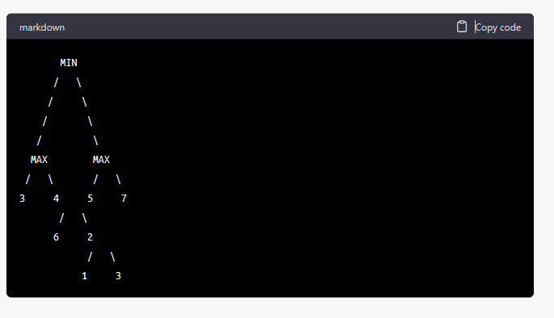

Next, we apply the Alpha-Beta pruning algorithm to this game tree to reduce the number of nodes that need to be evaluated. The algorithm uses two values, alpha and beta, to keep track of the minimum and maximum values of the opponent, respectively.
- At the root node (MIN), the initial alpha value is negative infinity, and the beta value is positive infinity.
- We start from the rightmost child of the root node, and evaluate the MAX node with value 5.
- The beta value is updated to the minimum of the current beta value (positive infinity) and the MAX node's value (5), which results in beta = 5.
- The next MAX node has a value of 7. Since 7 is greater than beta (5), we can prune this node and all its children, as they will not change the outcome.
- Now, we evaluate the MAX node with value 4. Since it is less than beta (5), we continue evaluating its children.
- The next MIN node has a value of 6, which is greater than alpha (negative infinity). So, we update the alpha value to 6.
- The next MIN node has a value of 2. Since it is less than alpha (6), we continue evaluating its children.
- The next MAX node has a value of 1, which is less than beta (5). So, we continue evaluating its children.
- The next MIN node has a value of 3, which is greater than alpha (6). So, we update the alpha value to 3.
- The next MIN node has a value of 5, which is greater than beta (5). So, we prune this node and all its children.
The final pruned game tree is shown below:
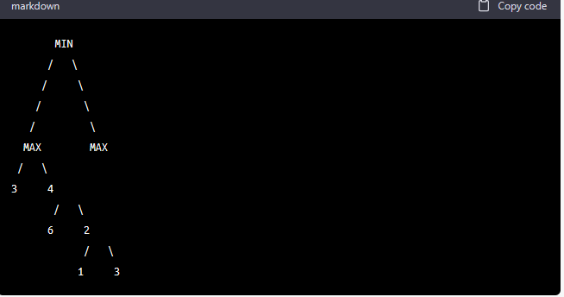
As we can see, the pruning of the two MAX nodes and their children reduces the number of nodes that need to be evaluated, improving the efficiency of the search process.

Chapter 06
What do you know about the 'future state of decision network'?
As the name suggests, the future state of decision network refers to the expected outcomes or consequences of different decisions that can be made in a decision network. In other words, it represents the impact of various decisions on the state of the world.
Decision networks use probabilities and decision nodes to model the uncertain events and decision points, respectively, and then calculate the expected utilities (i.e., the values or benefits associated with different outcomes) based on these probabilities and decision nodes. By doing so, decision networks can help decision-makers identify the best decision to make in a given situation.
To calculate the future state of decision network, one needs to propagate the probabilities and utilities through the network from the decision nodes to the root node. This can be done using various methods, such as the value of perfect information (VPI) or the expected value of perfect information (EVPI), which allow decision-makers to assess the potential gains or losses associated with acquiring additional information about the uncertain events in the decision network.
Decision theory = Probability theory + Utility theory

Basic principle of decision theory

Justify the suitability of Bayesian network for uncertainty management in decision network
Bayesian networks are a suitable approach for managing uncertainty in decision networks for several reasons. Firstly, they provide a structured and intuitive way of representing uncertain knowledge by modeling the conditional dependencies between variables. This allows for probabilistic inference and decision making in complex systems with uncertain and interrelated variables.
Secondly, Bayesian networks can handle incomplete and ambiguous data, as well as easily incorporate new evidence or data as it becomes available. This flexibility and adaptability make them ideal for decision-making scenarios where uncertainty is inherent and dynamic.
Thirdly, Bayesian networks can effectively handle situations where the number of variables is large or the joint probability distribution is too complex to model explicitly. The use of conditional probabilities for each variable given its parents allows for the decomposition of the problem into smaller and more manageable components.
Overall, Bayesian networks are a powerful and flexible tool for managing uncertainty in decision networks, and their ability to incorporate probabilistic inference and dynamic updates make them particularly suitable for real-world decision-making scenarios.
Degree of belief
In the context of artificial intelligence and decision making, the degree of belief refers to the level of confidence or uncertainty that an agent has about a particular proposition or event. It represents the agent's subjective assessment of the likelihood of an event occurring, based on the available evidence and knowledge. The degree of belief is typically represented using probabilities, which provide a quantitative measure of uncertainty. The probability theory is used to reason about the degree of belief, update it as new evidence becomes available, and make decisions based on it.

Degree of usefulness
In the context of decision making, the degree of usefulness refers to the value or desirability assigned to different outcomes or alternatives. Utility theory provides a framework for quantifying an agent's preferences and assigning a numerical value, known as utility, to each possible outcome. The degree of usefulness is reflected in the shape of the utility function, which maps the different outcomes to their corresponding utilities. The degree of usefulness can be used to guide decision making by selecting the alternative that has the highest expected utility, taking into account the agent's beliefs and uncertainties about the outcomes.

Advantage and disadvantage of inference of full join probability distribution
Advantage:
- Full joint probability distribution provides a complete and accurate representation of the relationship between all variables in the domain.
- It allows for exact inference, meaning that any query can be answered with certainty given the probabilities in the table.

Disadvantage:
- The size of the table grows exponentially with the number of variables in the domain, making it impractical or impossible to compute and store for large domains.
- Updating the probabilities in the table can be computationally expensive and time-consuming.
- It does not allow for efficient inference or reasoning, as calculating probabilities for specific events or conditions requires summing over all possible combinations of values for the other variables in the domain.

Two key components of decision theory
are probability theory and utility theory. In a decision network, these components can be incorporated as follows:
Probability theory: In a decision network, probability theory is used to quantify the uncertainty associated with the various possible outcomes. The relationships between the variables in the decision network are specified using conditional probability tables (CPTs), which specify the probability of each outcome given the values of its parent nodes.
Utility theory: In a decision network, utility theory is used to quantify the value or desirability of the various possible outcomes. This is typically done using utility nodes, which represent the utility associated with each possible outcome.

Major components of Bayesian network
The major components of a Bayesian network are:
- Nodes: A node represents a random variable in the domain being modeled.
- Arcs (also called edges): These are directed connections between nodes that represent the parent-child relationships between variables. The arc from node A to node B indicates that A is a parent of B.
- Conditional Probability Tables (CPTs): Each node has a CPT that quantifies the effect of its parents on the node, i.e., it specifies the probability distribution of the node given the values of its parent nodes.
- Graph structure: The directed acyclic graph structure of the network defines the conditional independence relationships among the variables. Specifically, a node is conditionally independent of all other nodes in the network, given its parents.
- Inference algorithms: These are used to perform probabilistic inference, i.e., to compute the posterior probabilities of some variables given evidence (observed values) and the network structure and parameters.
- Learning algorithms: These are used to learn the structure and parameters of the network from data. There are several types of learning algorithms, including parameter estimation and structure learning.
Planner search
Planner search strategy is a technique used to solve problems in which the agent needs to find a sequence of actions to achieve a particular goal. The agent builds a search tree, where each node represents a state of the world, and the edges represent the actions that can be taken to move from one state to another. The planner search strategy explores this tree to find a path from the initial state to the goal state. The objective is to find an optimal sequence of actions that achieves the goal.
Game-playing search strategy
On the other hand, game-playing search strategy is used to solve games, where the objective is to find the best move for a player given the current state of the game. The game-playing search strategy builds a search tree that represents all possible moves that can be made from the current state of the game. It then uses a scoring function to evaluate each move and selects the move with the highest score.
So, planner search strategy focuses on finding a sequence of actions that lead to a goal state, but game-playing search strategy focuses on finding the best move given the current state of the game.

Quiz 04 (Assignment)
Explain the termination condition of a typical Genetic algorithm. (4)
A typical Genetic Algorithm (GA) terminates based on one or more termination conditions. The most common termination conditions for a GA are:
- Number of generations: A GA can be set to run for a fixed number of generations. Once the specified number of generations is reached, the algorithm stops and the best solution found so far is returned.
- Fitness threshold: A GA can be set to stop once a solution is found that meets a certain fitness threshold. This threshold can be set based on the problem being solved. For example, if the goal is to find the global minimum of a function, the algorithm can stop once a solution is found that is within a certain tolerance of the true global minimum.
- Time limit: A GA can also be set to run for a fixed amount of time. Once the time limit is reached, the algorithm stops and the best solution found so far is returned.
- No improvement: A GA can be set to stop if there is no improvement in the best solution found after a certain number of generations. This is useful in situations where the algorithm is stuck in a local optimum and is unlikely to find a better solution.
It's worth noting that it's possible to combine multiple termination conditions to suit the requirements of the problem you are trying to solve. For example, you can set the algorithm to stop after a certain number of generations or when a solution is found that meets a certain fitness threshold or when there is no improvement for a certain number of generations.
In summary, the termination condition of a Genetic Algorithm is a set of rules that govern when the algorithm should stop running. It's a way to control the computational time and resources used by the algorithm. The most common termination conditions are based on the number of generations, fitness threshold, time limit and no improvement.

Summary 1:
A Genetic Algorithm (GA) is an optimization algorithm that uses principles of natural selection and genetics to find the best solution for a problem. The algorithm terminates when a set of conditions are met, known as termination conditions. The most common termination conditions for a GA include a fixed number of generations, reaching a fitness threshold, a time limit, or no improvement in the best solution. The conditions can be combined to fit the requirements of the problem being solved. The termination condition is important in controlling the computational resources and time used by the algorithm, making it more efficient. The most popular termination conditions are based on the number of generations, fitness threshold, time limit, and no improvement in the best solution.
Advantages of Genetic Algorithms:
- Global Optimization: Genetic algorithms are well suited for finding the global optimum in a search space, as they can explore a large number of potential solutions.
- Robustness: They are relatively robust to changes in the problem and can find good solutions even if the problem is not well defined or if the data is noisy.
- Parallelizability: Genetic algorithms are easily parallelizable, as each candidate solution can be evaluated independently.
- Handling Constraints: Genetic algorithms can handle constraints easily by defining a fitness function that penalizes solutions that violate constraints.
Disadvantages of Genetic Algorithms:
- Time Complexity: Genetic algorithms can be computationally expensive, especially for complex problems or large search spaces.
- Overfitting: The algorithm may overfit to the training data and produce solutions that are not generalizable.
- Convergence: The algorithm may converge to a suboptimal solution if the population becomes dominated by a single solution.

Analyze the role of Hill-climbing Local Search strategy in finding reasonable solutions to hard problems with no specific goal states. (8)
Hill-climbing is a local search optimization technique used to find optimal solutions for problems with no specific goal states. The algorithm starts by generating a random solution and then continually modifies it to find a better solution. The modifications made to the solution are usually small and aim to improve the value of the solution. After each modification, the new solution is evaluated and compared to the previous solution. If it is an improvement, it becomes the current solution and the process continues. If the new solution is worse, the algorithm reverts to the previous solution and tries a different modification. The process repeats until a satisfactory solution is found or a local maximum is reached.

Hill-climbing Local Search is a heuristic optimization algorithm that is commonly used to find approximate solutions to hard problems with no specific goal states. The algorithm starts with an initial solution and iteratively makes small changes to the solution in an attempt to improve it. The changes are made based on the principle of "hill-climbing", which means that the algorithm tries to move towards a better solution by only making changes that improve the current solution.
The algorithm typically works by defining a set of possible solutions and a cost or fitness function that assigns a value to each solution. The algorithm then starts with an initial solution and evaluates its fitness. The algorithm then generates a set of neighboring solutions by making small changes to the current solution. The algorithm then selects the neighbor with the best fitness as the new current solution. This process is repeated until a local maximum (or "hill") is reached, where no further improvements can be made by considering only the neighbors of the current solution.
Hill-climbing Local Search can be applied to a wide range of problems, such as finding the minimum or maximum of a function, solving constraint satisfaction problems, and optimization problems. The algorithm is simple to implement and can quickly find reasonably good solutions. However, the algorithm may get stuck in a local optimum that is not the global optimum. To avoid this problem, the algorithm can be combined with other techniques such as random restarts or simulated annealing to increase the chances of finding the global optimum.
In a nutshell, Hill-climbing Local Search strategy is a simple and efficient optimization algorithm that can quickly find reasonably good solutions to hard problems with no specific goal states. It is widely used in many fields such as machine learning, operations research, and computer science. However, the algorithm may not find the global optimum and the results may depend on the initialization, thus it's important to combine it with other techniques to increase the chances of finding the global optimum.
Summary 1:
Hill-climbing is a local search strategy that is used to find an optimal solution for a problem. It is often used to solve problems with no specific goal states, where finding a solution with a high value is desirable. Hill-climbing works by starting from a randomly generated solution and iteratively making small changes to it to find a better solution. The new solution is then evaluated and compared to the previous solution. If it is better, the new solution becomes the current solution and the process continues. If it is worse, the algorithm will revert to the previous solution and try a different change. This process continues until a local maximum or a satisfactory solution is found. Hill-climbing is simple, fast and effective in finding good solutions for many problems. However, it can become trapped in local maxima and not find the global optimum solution.

Summary 2:
Hill-climbing is a simple and efficient technique that can be applied to a wide range of problems, including mathematical optimization problems and problems in artificial intelligence. However, it has some limitations. For example, it can easily become trapped in local maxima and not find the global optimum solution.
In conclusion, Hill-climbing is an effective local search strategy for finding reasonable solutions to hard problems with no specific goal states. While it has some limitations, it remains a popular optimization technique due to its simplicity and efficiency.
Advantages of Hill Climbing Algorithms:
- Simplicity: Hill climbing algorithms are simple to understand and implement, making them a popular choice for beginners.
- Speed: Hill climbing algorithms are relatively fast and can quickly find good solutions in small search spaces.
Disadvantages of Hill Climbing Algorithms:
- Local Optima: Hill climbing algorithms can get stuck in local optima and fail to find the global optimum.
- Sensitivity to Initial Conditions: The algorithm's performance can be heavily influenced by the initial conditions, and it may find different solutions for different starting points.
- Unsuitable for Multi-modal Problems: Hill climbing algorithms are not well suited for problems with multiple local optima, as they are unlikely to find the global optimum.

Random restart hill climbing, stochastic hill-climbing, and first-choice hill-climbing are different variations of the hill-climbing algorithm.
Random restart hill climbing is a meta-heuristic optimization algorithm that involves running multiple instances of hill-climbing from different randomly generated initial states. If a local optimum is reached, the algorithm restarts with a new random initial state. The best solution found across all instances is returned as the final result.
Stochastic hill-climbing, on the other hand, involves making random moves even when a better state is available. This randomness helps the algorithm avoid getting stuck in local optima.
First-choice hill-climbing, also known as greedy hill-climbing, only considers the best move available at each step, instead of randomly selecting a move. This makes the algorithm faster, but it may get stuck in local optima.
In summary, random restart hill-climbing is a combination of hill-climbing and random restarts, while stochastic hill-climbing adds randomness to avoid local optima, and first-choice hill-climbing is a greedy approach to hill-climbing.

Real life examples of Random restart hill climbing, Stochastic Hill-climbing, First-choice Hill-climbing
Here are some real-life examples of Random restart hill climbing, Stochastic Hill-climbing, and First-choice Hill-climbing:
Random restart hill climbing:
- Optimizing the parameters of a machine learning model, where random restarts are used to avoid getting stuck in local optima.
- Solving the traveling salesman problem, where the starting point is randomly chosen, and the algorithm is restarted several times to improve the solution.
Stochastic Hill-climbing:
- Optimizing the hyperparameters of a neural network, where random perturbations are made to the current solution to improve it.
- Solving the knapsack problem, where the algorithm randomly selects a candidate solution and then chooses to accept or reject it based on its fitness.
First-choice Hill-climbing:
- Solving the n-queens problem, where the algorithm selects the first feasible solution from the list of possible moves.
- Solving the 8-puzzle problem, where the algorithm chooses the first feasible move that improves the current solution.

Present an evaluation of the A* search strategy. (8)
A* is relatively efficient, its time and space complexity are both O(b^d) where b is the branching factor and d is the depth of the optimal solution. However,
A* can be less efficient in cases where the graph is very large or the heuristic function is not well-suited to the problem, as it may expand a large number of nodes without finding the goal. Additionally, it can be memory-intensive, as it requires maintaining a priority queue of nodes to be expanded.

The A* search strategy is a popular algorithm for finding the shortest path in a graph. It combines the strengths of both breadth-first search and uniform-cost search by using a heuristic function to guide the search towards the goal. This heuristic function estimates the cost to reach the goal from a given node, and the A* algorithm uses this estimate to prioritize which nodes to expand next.
One of the main advantages of A* is that it is guaranteed to find the optimal solution, as long as the heuristic function used is admissible (never overestimates the actual cost to the goal) and consistent (the estimated cost to move from one node to another is less than the estimated cost to move from that node to the goal plus the estimated cost to move from the first node to the second node).
A* is widely used in pathfinding and navigation problems, such as video games and self-driving cars. It is also used in other fields such as robotics, logistics, and logistics planning.
A* is relatively efficient, its time and space complexity are both O(b^d) where b is the branching factor and d is the depth of the optimal solution. However,
A* can be less efficient in cases where the graph is very large or the heuristic function is not well-suited to the problem, as it may expand a large number of nodes without finding the goal. Additionally, it can be memory-intensive, as it requires maintaining a priority queue of nodes to be expanded.
Overall, the A* search algorithm is a powerful and versatile method for finding the shortest path in a graph. Its ability to use a heuristic function to guide the search makes it a popular choice for many real-world applications, and its guarantee of finding an optimal solution makes it well-suited for critical systems. However, it does have some limitations in terms of efficiency and memory usage, and careful consideration of the problem and the heuristic function used is needed for optimal performance.

Summary 1:
The A* search strategy is a widely used algorithm for finding the shortest path in a graph. It's known for its efficiency and versatility in real-world applications such as video games, self-driving cars, robotics, and logistics planning. The heuristic function estimates the cost to reach the goal from a given node and the A* algorithm uses this estimate to prioritize which nodes to expand next.
One of the key advantages of A* is its guarantee of finding the optimal solution if the heuristic function used is admissible and consistent. However, A* can be less efficient in cases where the graph is large or the heuristic function is not well-suited to the problem, and it can also be memory-intensive as it requires maintaining a priority queue of nodes to be expanded.
In conclusion, the A* search strategy is a powerful tool for finding the shortest path in a graph, but careful consideration must be given to the problem and the heuristic function used for optimal performance. Its ability to use a heuristic function to guide the search and guarantee of finding an optimal solution make it a popular choice for many real-world applications.
Advantages of A* search algorithm:
- Guaranteed to find the optimal solution if the heuristic function is admissible and consistent.
- Efficient, with time and space complexity of O(b^d) where b is the branching factor and d is the depth of the optimal solution.
- Versatile, widely used in fields such as pathfinding, navigation, robotics, logistics, and logistics planning.
- Utilizes a heuristic function to guide the search, making it a popular choice for many real-world applications.
Disadvantages of A* search algorithm:
- Can be less efficient in cases where the graph is very large or the heuristic function is not well-suited to the problem.
- Memory-intensive, requires maintaining a priority queue of nodes to be expanded.
- Can expand a large number of nodes without finding the goal if the heuristic function is not well-suited to the problem.
- Requires careful consideration of the problem and the heuristic function used for optimal performance.

Define beam search and stochastic
Beam search is a search algorithm used to find the best solutions among a large set of candidates. It works by considering only a limited number of the best solutions, called "beams," at each step of the search, rather than considering all solutions. This reduces the computational complexity of the search and makes it possible to find good solutions even in large search spaces.
Stochastic refers to a process that is random or probabilistic in nature. In the context of search algorithms, stochastic refers to algorithms that incorporate randomness or uncertainty into their search process. This can be used to escape from local optima and explore different parts of the search space, leading to a better chance of finding a global optimum.

Part B: Machine Learning

Supervised, unsupervised and Reinforcement learning
Difference between Supervised, unsupervised and Reinforcement learning in a table
 | Supervised Learning | Unsupervised Learning | Reinforcement Learning
Definition | A supervised learning algorithm is given a labeled dataset and must learn a function that maps inputs to outputs. | Unsupervised learning algorithms take in data without predefined labels and must determine the structure and relationships in the data. | Reinforcement learning involves training an agent to make a series of decisions based on the state of the environment and the rewards received from its actions.
Input | Labeled data | Unlabeled data | State of the environment
Output | Predicted output | Clustered or grouped data | Decisions/actions
Purpose | Classification and regression problems | Exploring and analyzing data to identify patterns and relationships | To maximize the reward received by the agent
Example | Predicting the price of a house based on its attributes | Clustering customer data to identify patterns in customer behavior | Training a robot to navigate through a maze and reach the end goal
Key Characteristics | Given labeled data, maps inputs to outputs | Discovering patterns and relationships in data | Making decisions to maximize rewards

Inductive vs deductive learning in a table with example
 | Inductive Learning | Deductive Learning
Definition | Inductive learning is a method of learning by observing and generalizing from examples. | Deductive learning is a method of learning by applying logic and reasoning to reach a conclusion.
Approach | Observing and generalizing from examples | Reasoning and applying logical rules
Example | Observing that all birds have wings and generalizing that all birds can fly. | Based on the rule that all birds have wings and can fly, deducing that a penguin is a bird.
Key Characteristics | Bottom-up approach, learning from observations and examples | Top-down approach, starting from a general principle and applying it to specific cases
Real-World Example | Learning to recognize a dog based on observing many examples of dogs | Solving a mathematical equation by applying known formulas and rules

K-Nearest Neighbors (KNN)
towardsdatascience.com /how-to-find-the-optimal-value-of-k-in-knn-35d936e554eb
How to find the optimal value of K in KNN? - Towards Data Science
Visualize error rate vs. K plot to find the most suitable K value.
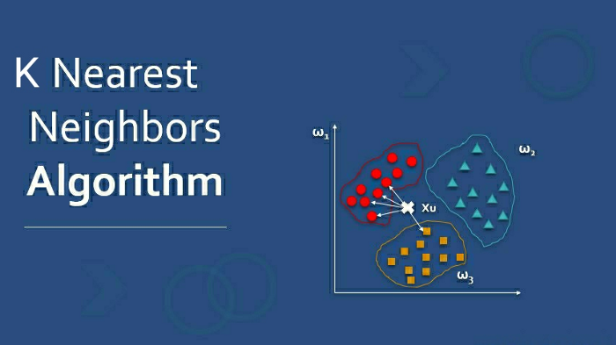
Figure 1: Photo via educba.com
Introduction
K-Nearest Neighbors is the supervised machine learning algorithm used for classification and regression. It manipulates the training data and classifies the new test data based on distance metrics. It finds the k-nearest neighbors to the test data, and then classification is performed by the majority of class labels.
Selecting the optimal K value to achieve the maximum accuracy of the model is always challenging for a data scientist. I hope you all know the basic idea behind the KNN, yet I will clarify an overview of knn later in this article. For a comprehensive explanation of working of this algorithm, I suggest going through the below article:
Introduction to k-Nearest Neighbors: A powerful Machine Learning Algorithm
In this article, I will demonstrate the implementable approach to perceive the ideal value of K in the knn algorithm.
Table of Contents
- Overview of KNN
- Distance Metrics
- How to choose a K value?
- KNN model implementation
- Key Takeaways
Let’s start,
1. Overview of KNN
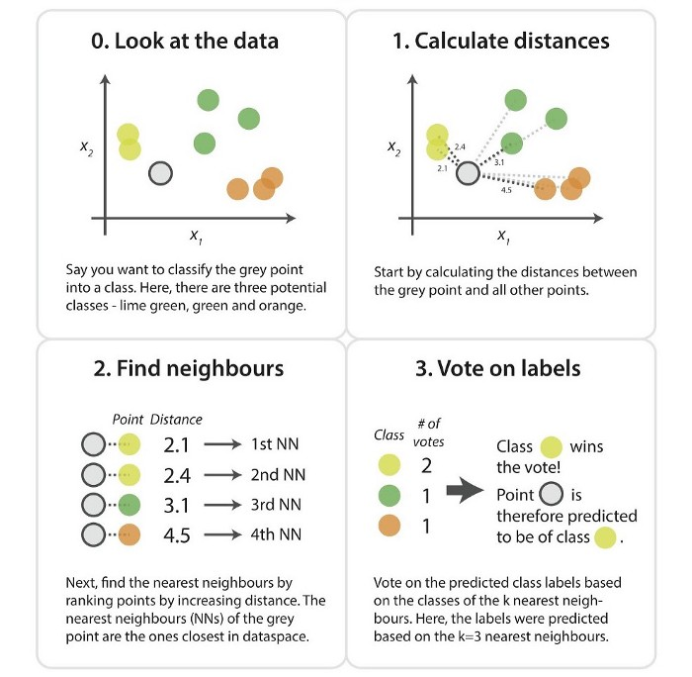
Figure 2: Photo via kdnuggets.com
Using K-Nearest Neighbor, we predict the category of the test point from the available class labels by finding the distance between the test point and trained k nearest feature values. By analyzing all the information, you will come up with a question,
How to calculate the distance?
Let me answer your enthusiastic question in the next section of distance metrics.
2. Distance Metrics
The distance metric is the effective hyper-parameter through which we measure the distance between data feature values and new test inputs.
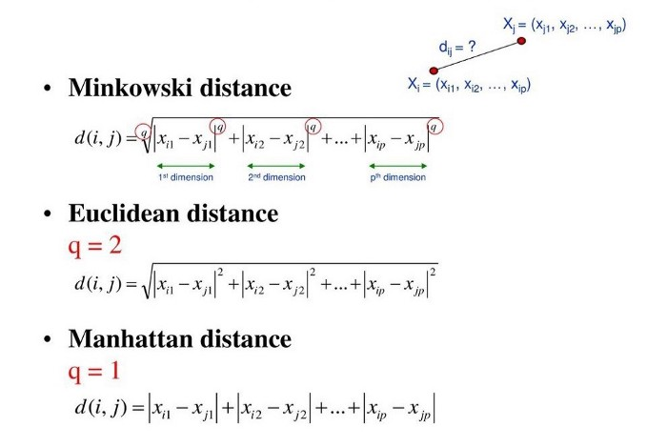
Figure 3: Photo via slideplayer.com
Usually, we use the Euclidean approach, which is the most widely used distance measure to calculate the distance between test samples and trained data values. We measure the distance along a straight line from point (x1, y1) to point (x2, y2).
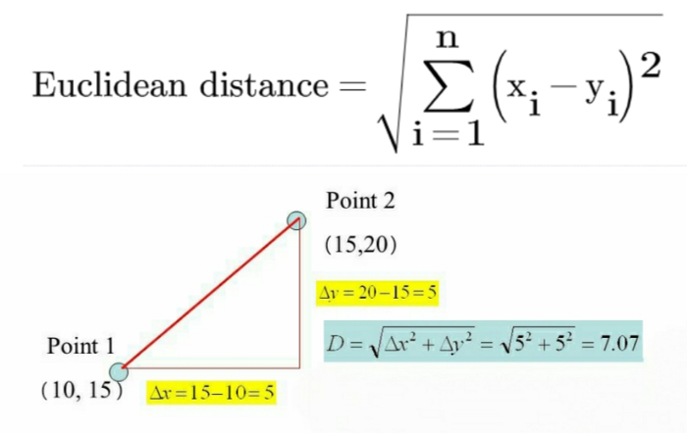
Figure 4: Photo via slideplayer.com
By analyzing the above computations, I hope that you understand how we calculate the Euclidean distance. Let’s throw some light on the prediction method in KNN.
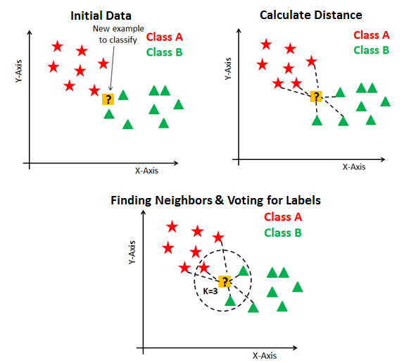
Figure 5: Photo via datacamp.com
To classify an unknown record:
- Initialize the K value.
- Calculate the distance between test input and K trained nearest neighbors.
- Check class categories of nearest neighbors and determine the type in which test input falls.
- Classification will be done by taking the majority of votes.
- Return the class category.
We understand the process of classifying an unknown record, but what about choosing an optimal K value?
Let’s answer it.
3. How to choose a K value?
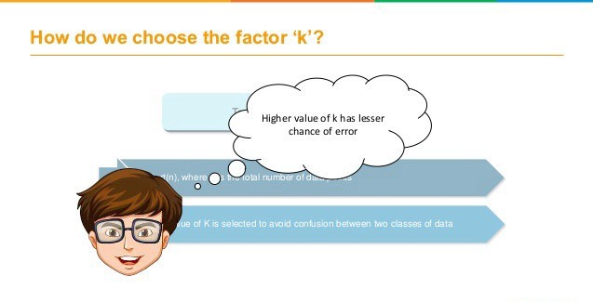
Figure 6: Photo via simplilearn.com
K value indicates the count of the nearest neighbors. We have to compute distances between test points and trained labels points. Updating distance metrics with every iteration is computationally expensive, and that’s why KNN is a lazy learning algorithm.
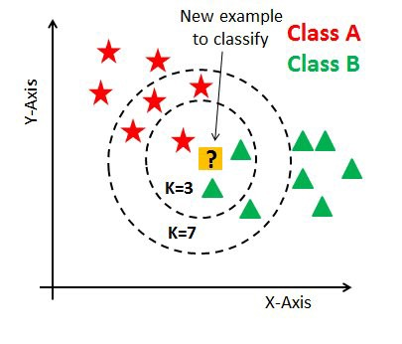
Figure 7: Photo via datacamp.com
- As you can verify from the above image, if we proceed with K=3, then we predict that test input belongs to class B, and if we continue with K=7, then we predict that test input belongs to class A.
- That’s how you can imagine that the K value has a powerful effect on KNN performance.
Then how to select the optimal K value?
- There are no pre-defined statistical methods to find the most favorable value of K.
- Initialize a random K value and start computing.
- Choosing a small value of K leads to unstable decision boundaries.
- The substantial K value is better for classification as it leads to smoothening the decision boundaries.
- Derive a plot between error rate and K denoting values in a defined range. Then choose the K value as having a minimum error rate.
Now you will get the idea of choosing the optimal K value by implementing the model.
4. KNN model implementation
Let’s start the application by importing all the required packages. Then read the telecommunication data file using read_csv() function.
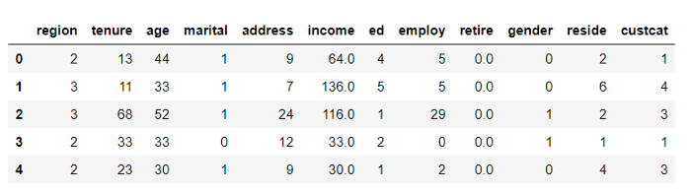
Figure 8: Primary dataset
As you can see, there are 12 columns, namely as region, tenure, age, marital, address, income, ed, employ, retire, gender, reside, and custcat. We have a target column, ‘custcat’ categorizes the customers into four groups:
- Basic Service
- E-Service
- Plus Service
- Total Service
Figure 9: Accuracy measure at K=4
- We collect all independent data features into the X data-frame and target field into a y data-frame. Then we manipulate the data and normalize it.
- After splitting the data, we take 0.8% data for training and remaining for testing purposes.
- We import the classifier model from the sklearn library and fit the model by initializing K=4. So we have achieved an accuracy of 0.32 here.
Now it’s time to improve the model and find out the optimal k value.
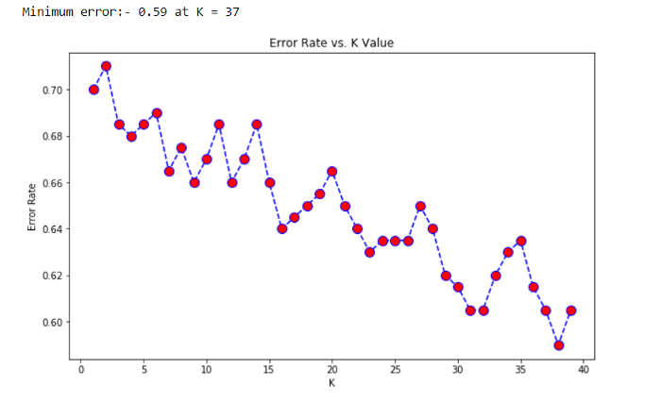
Figure 10: Error rate vs. K-value
From the plot, you can see that the smallest error we got is 0.59 at K=37. Further on, we visualize the plot between accuracy and K value.
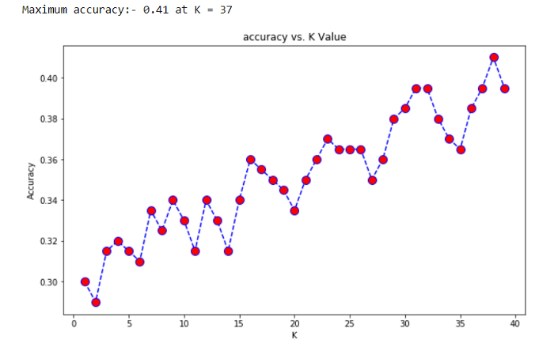
Figure 11: Accuracy vs. K value
Now you see the improved results. We got the accuracy of 0.41 at K=37. As we already derived the error plot and got the minimum error at k=37, so we will get better efficiency at that K value.
As our principal focus is on determining optimal K value but, you can perform exploratory data analysis and can achieve even greater accuracy. Data file and code are available in my GitHub repository.
5. Key Takeaways
- We obtained an accuracy of 0.41 at k=37, which is higher than the efficiency calculated at k=4.
- The small K value isn’t suitable for classification.
- The optimal K value usually found is the square root of N, where N is the total number of samples.
- Use an error plot or accuracy plot to find the most favorable K value.
- KNN performs well with multi-label classes, but you must be aware of the outliers.
- KNN is used broadly in the area of pattern recognition and analytical evaluation.
References: Elbow Method in Supervised Machine Learning
K-Nearest Neighbors (KNN) is known by several different names because of its different aspects of learning and reasoning.
- Memory-Based Reasoning: KNN is called memory-based reasoning because it memorizes all the training instances and uses them as a reference to make predictions for new instances. It does not learn a model from the data and does not make any assumptions about the underlying relationship between the features and the class labels.
- Example-Based Reasoning: KNN is also known as example-based reasoning because it uses examples to make predictions. The algorithm compares new instances with the training instances to find the closest neighbors and uses them as a basis for prediction.
- Instance-Based Learning: KNN is referred to as instance-based learning because it learns from instances or examples, not by creating a model or generalizing patterns from the data. The algorithm keeps all the training instances in memory and uses them directly for prediction.
- Lazy Learning: KNN is called lazy learning because it does not learn a model or make any generalizations about the data until a new instance is encountered for prediction. It is considered lazy because it does not actively learn from the training data and instead waits for new instances to make predictions.
K-Nearest Neighbors (KNN) and Support Vector Machines (SVMs) are both popular machine learning algorithms used for classification tasks. The main differences between these two classifiers are:
- Learning process: KNN is a lazy learning algorithm and does not actively learn from the training data. It simply memorizes the training instances and compares new instances to these instances to make predictions. On the other hand, SVMs learn a model from the data and use this model to make predictions.
- Computational complexity: KNN has a low computational complexity during training, as it only memorizes the training instances. However, it has a high computational complexity during prediction, as it needs to compare the new instance with all the training instances to find the nearest neighbors. SVMs have a high computational complexity during training, as they need to optimize the model to find the optimal hyperplane. However, they have a low computational complexity during prediction, as they only need to use the learned model to make predictions.
- Accuracy: KNN is generally considered to have lower accuracy compared to SVMs. However, it depends on the dataset and the problem. KNN is sensitive to noisy data and can be easily influenced by outliers, which can negatively impact its accuracy. SVMs are robust to noisy data and are less influenced by outliers, which leads to higher accuracy in many cases.
- Model complexity: KNN does not learn a model and does not make any assumptions about the data, which makes it simple and easy to use. SVMs, on the other hand, learn a complex model and make assumptions about the data, which can make them harder to use and understand.
- Handling non-linear data: KNN works well with linear data, but it can struggle with non-linear data. SVMs are able to handle non-linear data by transforming the data into a higher-dimensional space, where a linear boundary can be found.
In summary, KNN is a simple and easy-to-use algorithm that is best suited for small datasets and linear data. SVMs are more complex and accurate, but are best suited for large datasets and non-linear data.

Comparison between K-Nearest Neighbors (KNN) and Support Vector Machines (SVM) Classifiers:
Feature | KNN | SVM
Learning process | Lazy learning | Active learning
Computational complexity | Low during training, high during prediction | High during training, low during prediction
Accuracy | Lower | Higher
Model complexity | Simple, no assumptions | Complex, makes assumptions
Handling non-linear data | Struggles with non-linear data | Can handle non-linear data
Sensitivity to noise | Sensitive to noise | Robust to noise
Suitable for | Small datasets, linear data | Large datasets, non-linear data

Drawbacks of KNN
- Computationally expensive: The KNN algorithm requires a large amount of memory and computational power, especially when working with large datasets. This can make it slow and unsuitable for real-time applications.
- Curse of dimensionality: As the number of features in the data increases, the distance between data points becomes less meaningful. This leads to the so-called “curse of dimensionality,” where KNN may produce poor results due to the loss of information.
- Sensitive to irrelevant features: KNN can be sensitive to irrelevant features in the data, meaning that these features can have a significant impact on the results even though they are not relevant to the task at hand.
- Lack of model interpretation: KNN is a non-parametric algorithm, which means that it does not provide a clear understanding of the underlying relationships between the features and the target. This can make it difficult to interpret the results and to make decisions based on the model.
- Need to determine the value of K: In KNN, the value of K must be chosen carefully, as a small value of K may lead to overfitting (too much influence of outliers) while a large value of K may lead to underfitting (too much generalization).
- Not suitable for large datasets: As the size of the dataset grows, the computational time required to perform KNN increases significantly, making it unsuitable for large datasets.
- Limited to binary or multi-class classification: KNN is limited to binary or multi-class classification problems, and cannot be used for regression or other types of problems.

Eager Learning | Instance-based Learning
Constructs a general description of the target function based on training examples | Compares new problem instances with instances seen in training
Explicit description of target function on the whole training set | Constructs hypothesis directly from the training instances
Uses the same approximation to the target function | Does not use a pre-defined approximation of the target function
Must be learned based on training examples before input queries are observed | Does not require training before input queries are observed
May require more computation and memory resources during training | Less computation and memory resources required during training
May not perform well on new, unseen data | Better at adapting to new, unseen data
Examples include decision trees, naive Bayes, and logistic regression | Examples include k-Nearest Neighbor and memory-based reasoning methods.

Naïve Bayes — Pros and Cons
3 types of bayes
Normal distribution vs informed

